1. Introduction to MNO Certification for Automotive Applications
What is MNO Certification?
MNO (Mobile Network Operator) Certification is the approval process required by a cellular operator (e.g., Vodafone, AT&T, Deutsche Telekom) before a device is allowed to operate on their live network.
In automotive applications, this ensures the vehicle’s connectivity module is:
Network-compatible
Secure
Reliable over long lifecycles (10–15 years)
Safe for critical vehicle functions
Why MNO Certification is Critical in Automotive?
Vehicles use cellular connectivity for:
Telematics Control Units (TCU)
eCall systems
OTA software updates
Remote diagnostics
Vehicle tracking and fleet management
A non-certified device may:
Be blocked from the network
Cause network instability
Create cybersecurity risks
Fail regulatory audits

2. Cellular Network Compliance Requirements


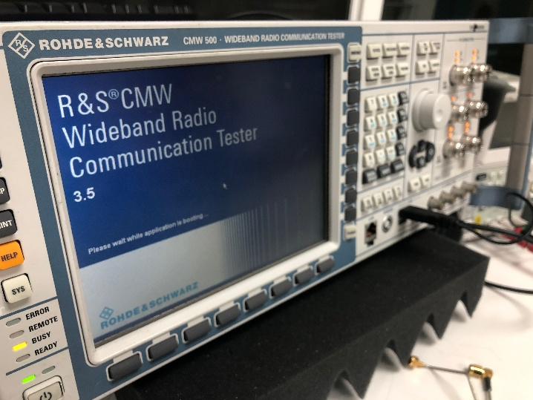

2.1 Standards Compliance
Automotive cellular devices must comply with global standards defined by:
3GPP – Defines LTE, LTE-M, NB-IoT, and 5G specifications
GSMA – Defines operator and SIM requirements
Key standards:
LTE Cat-1 / Cat-4 / Cat-M / NB-IoT
5G NR (for advanced automotive use cases)
VoLTE (mandatory for eCall in many regions)
2.2 Radio Frequency (RF) Compliance
Transmit power limits
Receiver sensitivity
Band support per region
Antenna performance
Coexistence with GNSS, Bluetooth, Wi-Fi
2.3 Protocol & Network Behaviour Compliance
Attach and detach procedures
Handover between cells
Idle and connected mode behaviour
Network recovery after signal loss
Power saving mechanisms (PSM, eDRX)
3. Security Requirements for Automotive MNO Certification
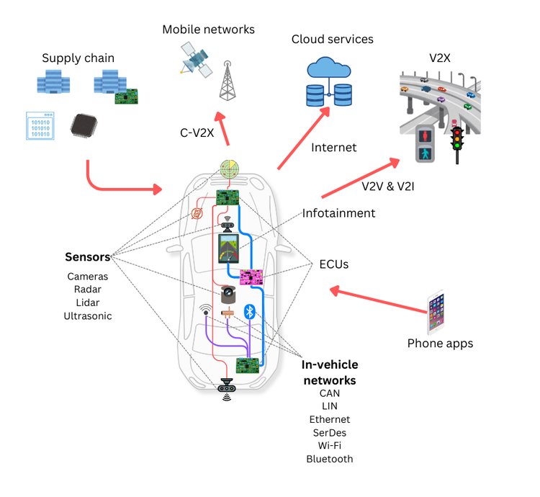


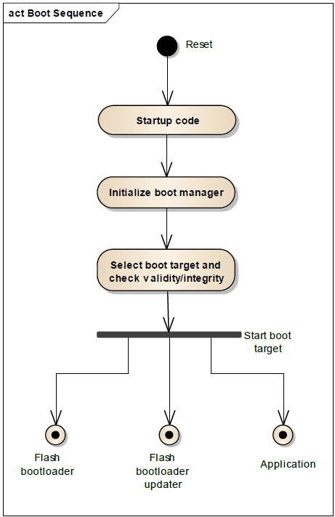
3.1 SIM & Subscription Security
Physical SIM (pSIM), eSIM, or iSIM
Secure storage of IMSI and keys
Proper authentication with network (AKA)

3.2 Device Security
Secure boot chain
Hardware Root of Trust
Encrypted firmware and storage
Protection against:
SIM cloning
Network spoofing
Unauthorized firmware changes
3.3 Network Security Compliance
TLS/IPSec usage for backend communication
Secure APN access
Firewall and port control
Protection against rogue base stations
3.4 Automotive-Specific Security Expectations
Compliance with ISO 21434 (road vehicle cybersecurity)
Separation between infotainment and safety-critical ECUs
Secure logging and traceability

4. Over-the-Air (OTA) Updates Requirements
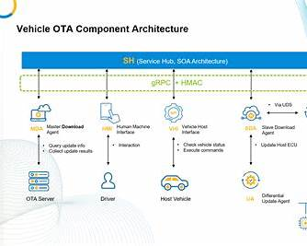
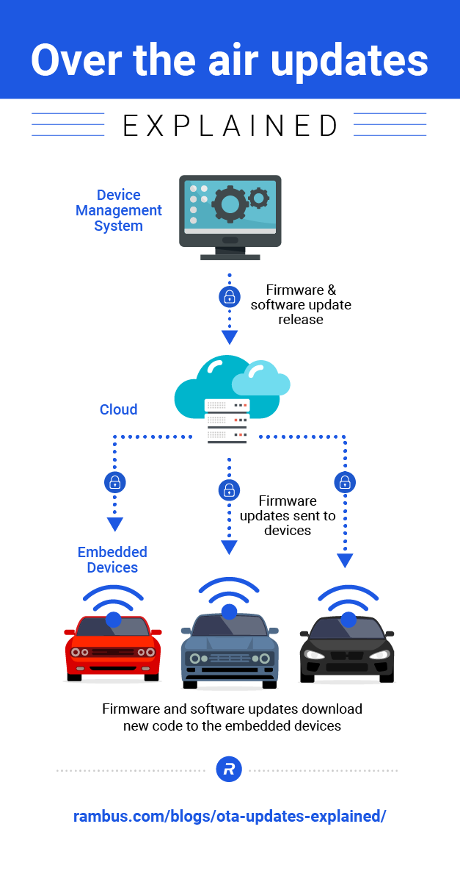

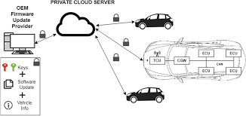
4
4.1 Why OTA is Mandatory
Vehicles cannot rely on service visits for software updates
Security patches and feature updates must be remote
Regulatory and safety updates may be legally required
4.2 OTA Technical Requirements
Delta and full firmware updates
Resume capability after interruption
Rollback mechanism in case of failure
Update integrity verification (hash, signature)
4.3 MNO Expectations for OTA
Controlled data usage
Network-friendly download behaviour
No excessive signalling load
Support for large file transfers

5. MNO Certification Process – Step by Step
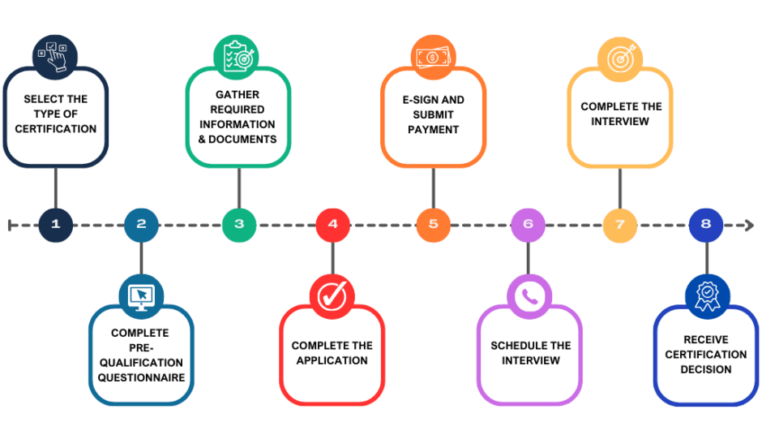
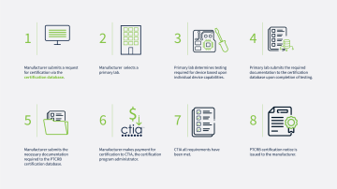

4
Step 1: Pre-Certification Preparation
Select target MNOs and regions
Review MNO certification documents
Confirm supported frequency bands
Freeze hardware design

Step 2: Conformance Testing
RF tests (3GPP)
Protocol stack testing
SIM and network attach tests
Conducted in certified labs
Step 3: Interoperability Testing (IOT)
Tests with live or simulated MNO network
Validates real-world behaviour
Focus on roaming and handover
Step 4: Field Testing
Drive tests in live networks
Urban, rural, and border scenarios
Power cycle and long-duration tests
Step 5: Certification Approval
Submission of test reports
Issue resolution if failures occur
Final MNO approval letter

6. Preparing a Device for MNO Certification Testing
Hardware Readiness
Production-level modem and antenna
Stable power supply
Automotive temperature support
Software Readiness
Stable modem firmware
Logging enabled
Network parameters configurable
OTA client integrated
Documentation Preparation
Device description
RF band support matrix
Software version details
Test configuration files

7. MNO Specific Tools and Test Procedures
Common Test Tools
Network simulators (Keysight, Rohde & Schwarz)
Protocol analysers
RF chambers
Drive test tools
MNO-Specific Test Areas
Network attach timing
Emergency call (eCall) behaviour
Data session recovery
SIM provisioning
Power consumption in idle state

8. Analysing Compliance Reports & Fixing Certification Issues
Common Certification Failures
Network attach failures
Excessive signalling
RF out-of-limit results
SIM authentication errors
OTA interruptions

How to Analyse Test Reports
Identify failed test cases
Check logs and traces
Correlate failures with network events
Validate against 3GPP specs
Issue Resolution Strategy
Firmware optimization
Modem parameter tuning
Antenna redesign if required
Re-testing and re-submission

9. Key Takeaways (Exam & Interview Ready)
MNO certification is mandatory for automotive cellular devices
Covers network compliance, security, and OTA
Automotive certification is stricter than consumer devices
Early preparation reduces certification delays
OTA and cybersecurity are top priorities for MNOs.

